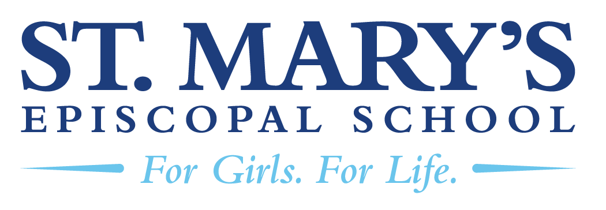

Head of School Search
St. Mary’s Episcopal School - Memphis, TN
The School
St. Mary’s Episcopal School is a college-preparatory school for girls from 2-year-old through 12th grade. Founded in 1847, St. Mary’s consistently ranks as among the top schools in Memphis and the state. The school’s mission is to “provide an unparalleled educational experience that challenges and supports each girl as she discovers her unique purpose and reaches her individual potential.”
St. Mary’s is a dynamic, close-knit community where girls and their families form lifelong connections. The community is rooted in the values of academic excellence, belonging, honor, Episcopal identity, and courage. Students have countless opportunities to explore their passions, build confidence, and grow as leaders. Every girl is empowered to discover her strengths and boldly pursue her dreams in a supportive environment.

Located on a beautiful, tree-lined campus in East Memphis, St. Mary’s intentionally blends tradition and innovation. Classic brick buildings and historic details sit alongside modern learning spaces: a new library and makerspace, updated science classrooms, and athletics facilities that include a turf field and a strength & conditioning center.
The Position
The next Head of School at St. Mary’s will step into a community that is thriving, supported by a talented, cohesive administrative team and strengthened by more than two decades of steady, visionary leadership. With a clearly defined mission, a healthy enrollment, and a deeply engaged school community, St. Mary’s offers its next leader an exceptional foundation on which to build.
Although an independent school, St. Mary’s maintains a close and enduring relationship with the Church of the Holy Communion, with whom it shares one of its campuses. True to the school’s Episcopal identity, St. Mary’s warmly welcomes students of all faith traditions and backgrounds, cultivating a community rooted in respect, belonging, and spiritual exploration.
Governance at St. Mary’s is strong and mission-driven. The School is led by a 26-member Board of Trustees composed of alumnae, current and past parents, and respected community leaders. The Episcopal Bishop of West Tennessee and the Rector of the Church of the Holy Communion serve as ex officio members of the board.
St. Mary’s is also poised for continued growth under its 2025–2030 Strategic Plan. This five-year roadmap centers on three major pillars: Institutional Excellence, Living Our Episcopal Identity, and Financial Strength. These priorities collectively guide the school’s academic vision, its commitment to community and faith, and its long-term sustainability.
The successful candidate will assume leadership on July 1, 2027, joining St. Mary’s at a pivotal and promising moment in its storied history.

To Apply
The position profile will be available by the end of December. Interested candidates are requested to contact the consultants listed below for preliminary discussion. We encourage prospective candidates to view the profile before applying.
Dave Davies / dave@educationgroup.com / 229-669-3555
Katherine Stuart/ katherine@educationgroup.com / 434-989-7054

